
Kew High School
Year 7
2019

Test CAT
Ecology- Adaptations, Interactions and Human Impact
Name:

Test Tips:
- Ensure you read each question carefully
- Highlight key words
- Ensure your answer is provided in full detail with correct scientific language
- Read over your answers to ensure that it reads well, has correct spelling, grammar and punctuation

Response Time
55 Minutes

Victorian Curriculum
Science Understanding, Biological sciences
- Interactions between organisms can be described in terms of food chains and food webs and can be affected by human activity (VCSSU093)
Science Inquiry skills, Recording and processing
- Construct and use a range of representations including graphs, keys and models to record and summarise data from students’ own investigations and secondary sources, and to represent and analyse patterns and relationships (VCSIS110)
- In fair tests, measure and control variables, and select equipment to collect data with accuracy appropriate to the task (VCSSU090)

Well Above the Standard

Above the Standard

At the Standard

Working towards the Standard

Emerging

Question 1.
Which of the following is a biotic factor in the environment?
- Soil type
- Rainfall
- Plant life
- Temperature

Question 2
Which one of the following terms could be seen as a characteristic that could aid survival of an organism?
- Biosphere
- Nocturnal
- Bioaccumulation
- Environment

Question 3.
The fish shown below is adapted to its habitat. Which characteristic will help it swim through the water?
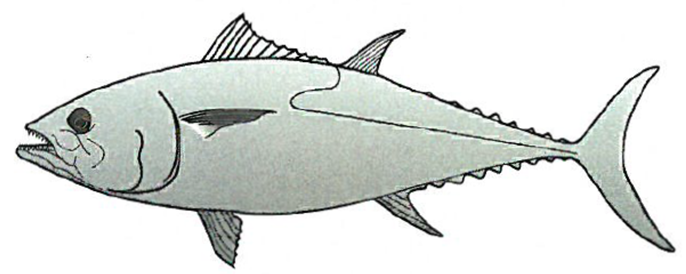 | - The dark colour of its tail and fins  - The long spines in its back fin  - Its streamlined shape  - Its gaping mouth and small teeth

Question 4
Identify the plant below that would be adapted to get the most water from its environment
A | 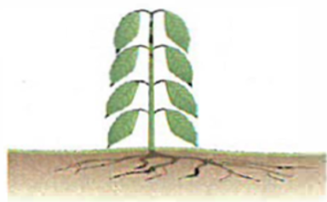 | B | 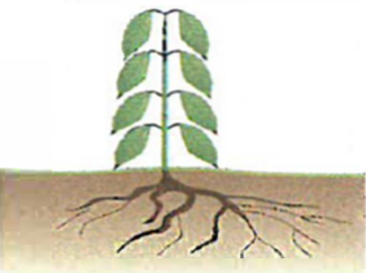 | C | 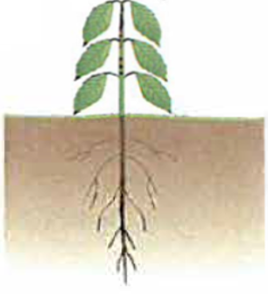 | D | 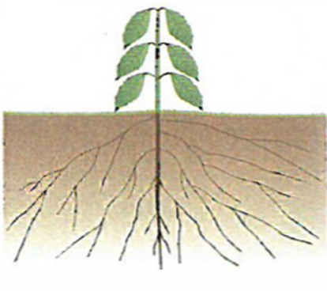

Question 5
Explain the difference between the terms living, non-living and dead.
……………………………………………………………………………………………………………………………………………………………………………………………………………………………………………………………………………………………………………………………………………………………………………………………………………………………..………………………………………………

Question 6
Fill in the table below.

Organism | Identify one adaptation | Explain how this adaptation helps the organism survive in its environment.
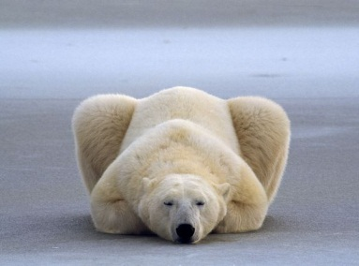Polar Bear
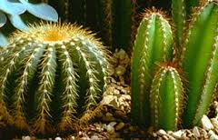
Cactus

Question 7.
Look at these three diagrams of birds’ feet.
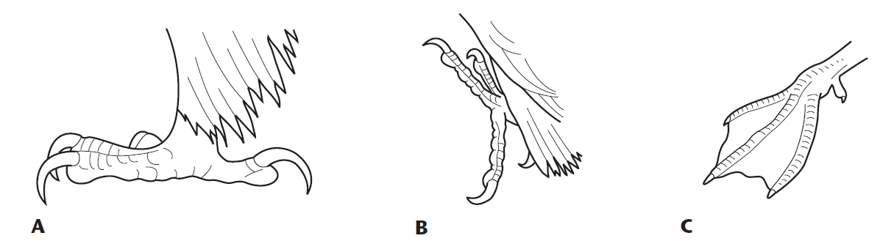
Which foot belongs to a bird adapted for swimming on water? Justify your answer.
……………………………………………………………………………………………………………………………………………………………………………………………………………………………………………………………………………………………………………………
Question 8.
There are seven characteristics (Mrs Gren) associated with living things. Fill in the blanks in the table below to give all characteristics and the description.

Characteristic | Description
Excretion | Getting rid of waste
Movement | The process of changing your position but not necessarily your size.
Nutrition | Taking in and using food
Reproduction | Making more living things of the same type
Respiration | Getting energy from food
Sensitivity | Detecting changes in the surroundings
Growth | The process of changing your size but not necessarily your position.

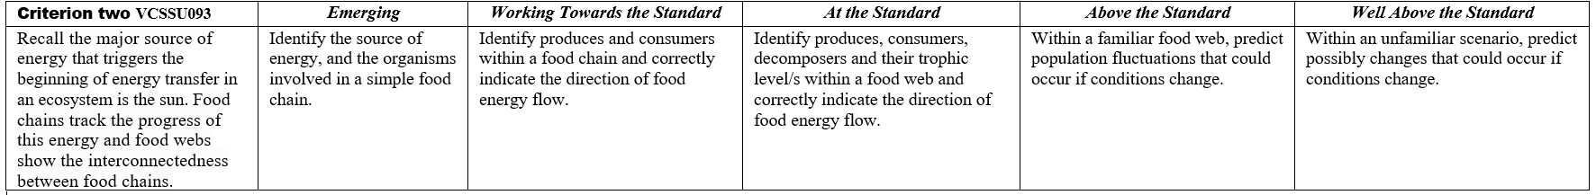

Question 9  Refer to the food web given to the right and select the CORRECT alternative from the 4 options listed below.  - The sun is the original source of energy for the following food chain  wildflowers mouse grass  - The grass is the original source of energy for the following food chain  hawk rabbit  - The sun is the original source of energy for the following food chain  grass mouse snake hawk  - The grass is the original source of energy for the following food chain  rabbit wildflower | 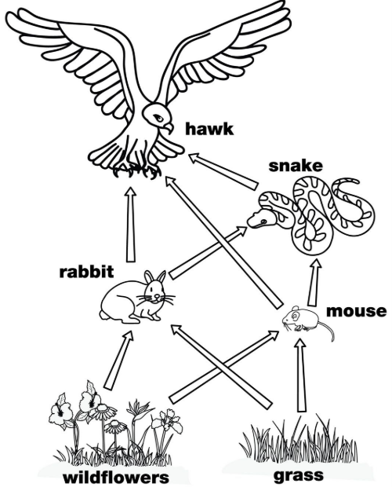

Question 10.
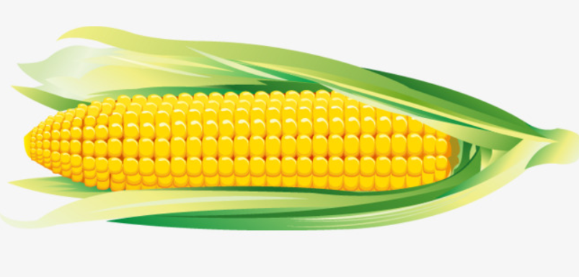 | 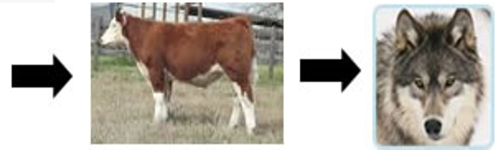
This diagram shows:
- One producer and two consumers
- One producer, one consumer and one decomposer
- One consumer and two producers
- One producer and two herbivores

Question 11
An organism that cannot make its own food is best described as
- Consumer
- Producer
- Mutualism
- Parasitism

Use the food web to the right to answer the following 3 questions

Question 12.  Identify the organism that is a third-order consumer.  - small fish  - kingfisher  - tadpole  - snail  Question 13.  Identify the organism that is both a second order and a third-order consumer.  - small fish  - kingfisher  - frog  - snail  Question 14.  A decomposer in the food web could be:  - kingfisher  - the sun  - plants  - bacteria | 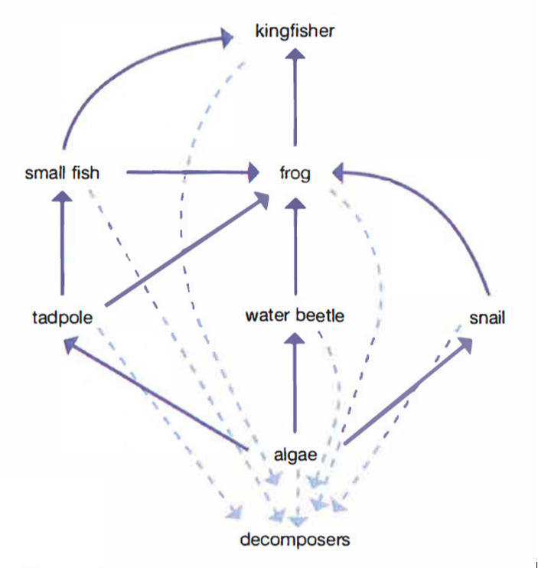

Question 15.  Consider the food web to the right.  a) Which two organisms compete for the same prey?  (i) ……………… (ii) …………………  b) Name one thing that the apple tree might compete for with other plants around it.  ………………………………………  c) Predict and explain two likely changes that could happen if all the thrushes caught a disease and died.  (i) ………………………………………  …………………………………………  …………………………………………  (ii) ………………………………………  …………………………………………  ………………………………………… | 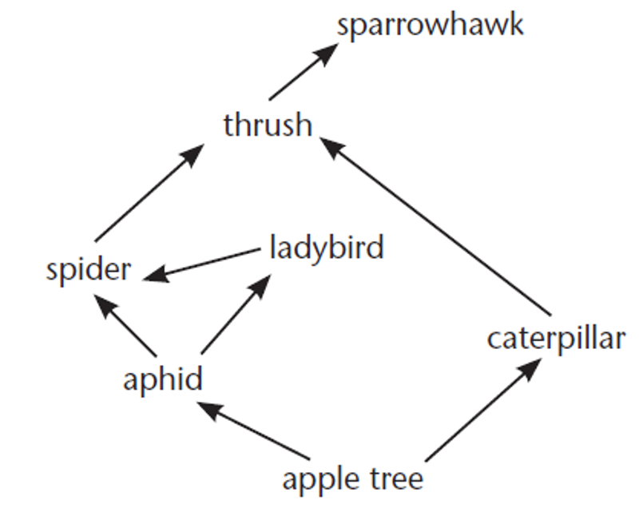

Question 16.
Consider the food web below showing the feeding relationships in the Southern Ocean ecosystem. (around the Antarctic)

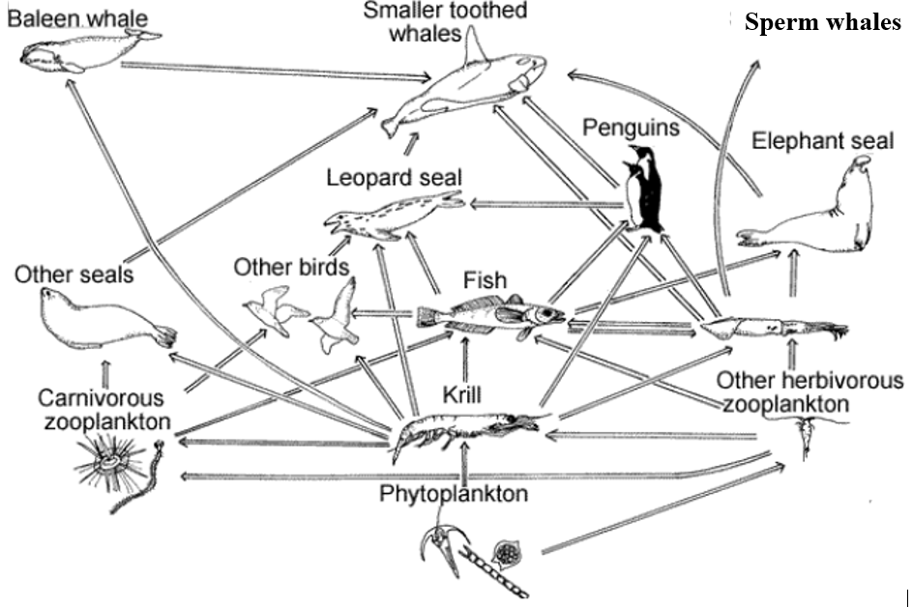
Krill are tiny animals - measuring about 6 cm in length and weighing about two grams. They feed on micro-size plants called phytoplankton They are thought to have the largest population of any species on Earth. Krill plays the important role of re-packaging vast amounts of food energy from the phytoplankton into their own body, making it available for marine predators in higher trophic levels. Because of this role they are called the keystone species.
- Explain what you think is meant by the term a keystone species.
………………………………………………………………………………………………………………………………………………………………………………………………………………………………………
- By referring to evidence from the food web, explain why krill are called a keystone species.
………………………………………………………………………………………………………………………………………………………………………………………………………………………………………

Question 17.
Which of the following is a type of symbiotic relationship?
- Commensalism
- Trophic level
- Sustainable ecosystem
- Temperature

Question 18
A symbiotic interaction in which one type of organism causes harm by living on or in another type of organism.
- Mutualism
- Parasitism
- Competition
- Prey

Question 19
A symbiotic interaction between organisms in which both the organisms benefit from the relationship and neither is harmed
- Mutualism
- Parasitism
- Competition
- Prey

Question 20
Consider the following information.

Many herbivores are found to have large numbers of special bacteria in their gut that can break down cellulose. Cellulose is a very large and strong molecule that gives plants the strength to stand upright without the aid of a skeleton.
On their own herbivores cannot break down cellulose, which means they miss out on many essential nutrients.
In this relationship between the herbivore and the bacteria, the herbivore provides the bacteria with a warm, moist environment with a constant supply of food. The bacteria break down cellulose. This enables the herbivore to access the nutrients in their cellulose-rich diet.

What is the type of symbiotic relationship is found between the herbivore and the bacteria? Justify your answer.
……………………………………………………………………………………………………………………………………………………………………………………………………………………………………………………………………………………………………………………………………………………………………………………………………………………………………………………………………………………………………………..………………………………………………

Question 21.
Which of the following is NOT an example of human impact on the environment?
- Air pollution in large congested cities
- The tides
- Contamination of ground water due to industrial processes
- Soil erosion due to land clearing

Question 22.
Mercury does not break down in the environment and may have toxic effects on the nervous, digestive and immune systems, and on lungs, kidneys, skin and eyes.
- In a science laboratory, heavy metal wastes like mercury and lead should not be poured down the sink. Why shouldn’t we pour heavy metals down the sink?
……………………………………………………………………………………………………………………………………………………………………………………………………………………………………………………………………………………………………………………

- Draw a food chain consisting of; small fish, large fish and a human and shows how bioaccumulation of mercury could occur.

- Which part of the food chain you have drawn above is most affected? Explain why.
……………………………………………………………………………………………………………………………………………………………………………………………………………………………………………………………………………………………………………………
- In this situation, predict the potential long-term impact on the ecosystem.
…………………………………………………………………………………………………………………………………………………………………………………………………………………………………………………………………………………………………………………………………………………………………………………………………

Question 23.
Lisa and Cameron made some observations over a period of a week about the feeding habits of a number of organisms in a small pond. Their results are listed below:

- Snails eat water plants and photosynthetic algae
- Tadpoles eat photosynthetic algae
- Small fish eat snails, photosynthetic algae and water plants
- Larger fish eat snails, small fish and tadpoles

Construct a food web below using the information above.
NOTE: DON’T DRAW THE ORGASISM – JUST WRITE THE NAME.

Question 24.
Foxes were introduced to Australia from England in the 1890s. By the 1950s, it was seen that foxes were having a big impact on many native species. In particular, foxes would eat kangaroos, wallabies, birds and koalas.
In an area of the Flinders Ranges in South Australia all foxes were completely eliminated in 1994. Due to effective fencing and heavy monitoring by the South Australian National Parks Authority, the area has remained fox free to this day.
The figure below shows the number of yellow-footed rock wallabies in this area of the Flinders ranges from 1994 – 2002.

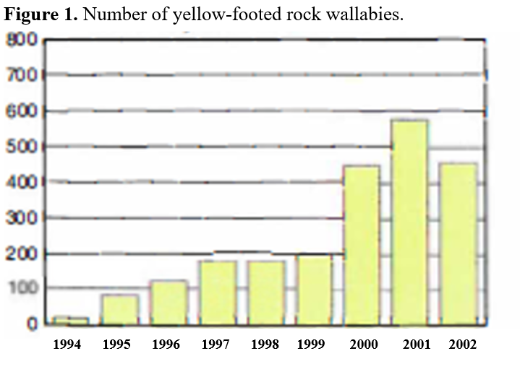
a) What trend is shown in the data above?
……………………………………………………………………………………………………………………………………………………………………………..
b) Is the type of graph selected to display the information appropriate? Explain.
……………………………………………………………………………………………………………………………………………………………………………..
c) Suggest a reason as to why the 2002 numbers may be less than the 2001 count.
……………………………………………………………………………………………………………………………………………………………………………..
d) The figure below shows a food web for this area before foxes were introduced. Add foxes into this food web and show their feeding relationships.
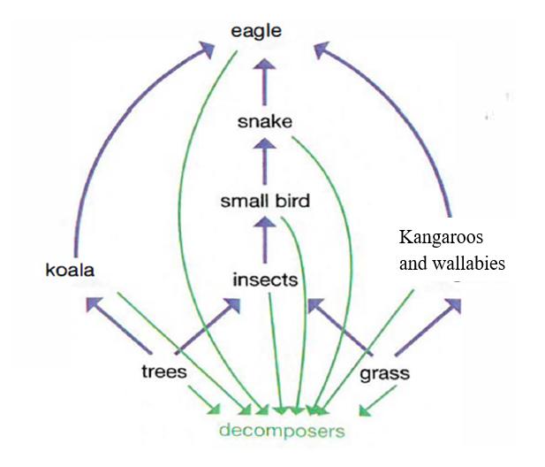

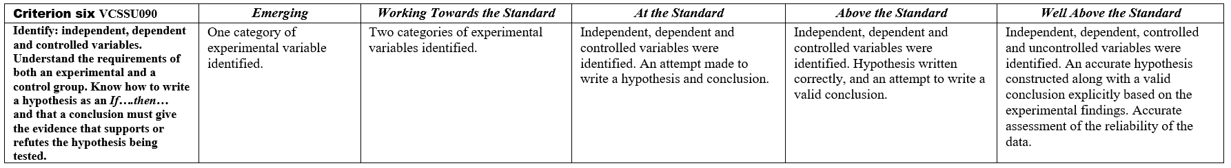
Homer notices that his shower is covered in a strange green slime. His friend Barney tells him that coconut juice will get rid of the green slime. Homer decides to check this out by spraying half of the shower with coconut juice. He sprays the other half of the shower with water. After 3 days of treatment, there is no change in the appearance of the green slime on either side of the shower. | 
Question 25.
Identify the independent variable
- Coconut juice
- The amount of green slime
- Sprays applied at the same time.
- Same chance of slime developing in any area of the shower

Question 26.
Identify the dependent variable
- Coconut juice
- The amount of green slime
- Sprays applied at the same time.
- Same chance of slime developing in any area of the shower

Question 27.
Identify a controlled variable
- Coconut juice
- The amount of green slime
- The water.
- Same chance of slime developing in any area of the shower

Question 28
Identify the control group
- The half of the shower that was sprayed with coconut juice spray
- The half of the shower that was not sprayed with coconut juice spray
- The coconut juice
- The time of day

Question 29.
Write a hypothesis for this experiment.
……………………………..……………………………………..……………………………………………………………………………………

Question 30.
What should Homer’s conclusion be?
…………………………..……………………………………..……………………………………..…………………………………………………………………………..…………………..………………………………

Question 31.
Comment of the reliability of the experiment?
……………………………..……………………………………..……………………………………………..……………………………………..…………………………………………………………………………………………………………………………………………………………

